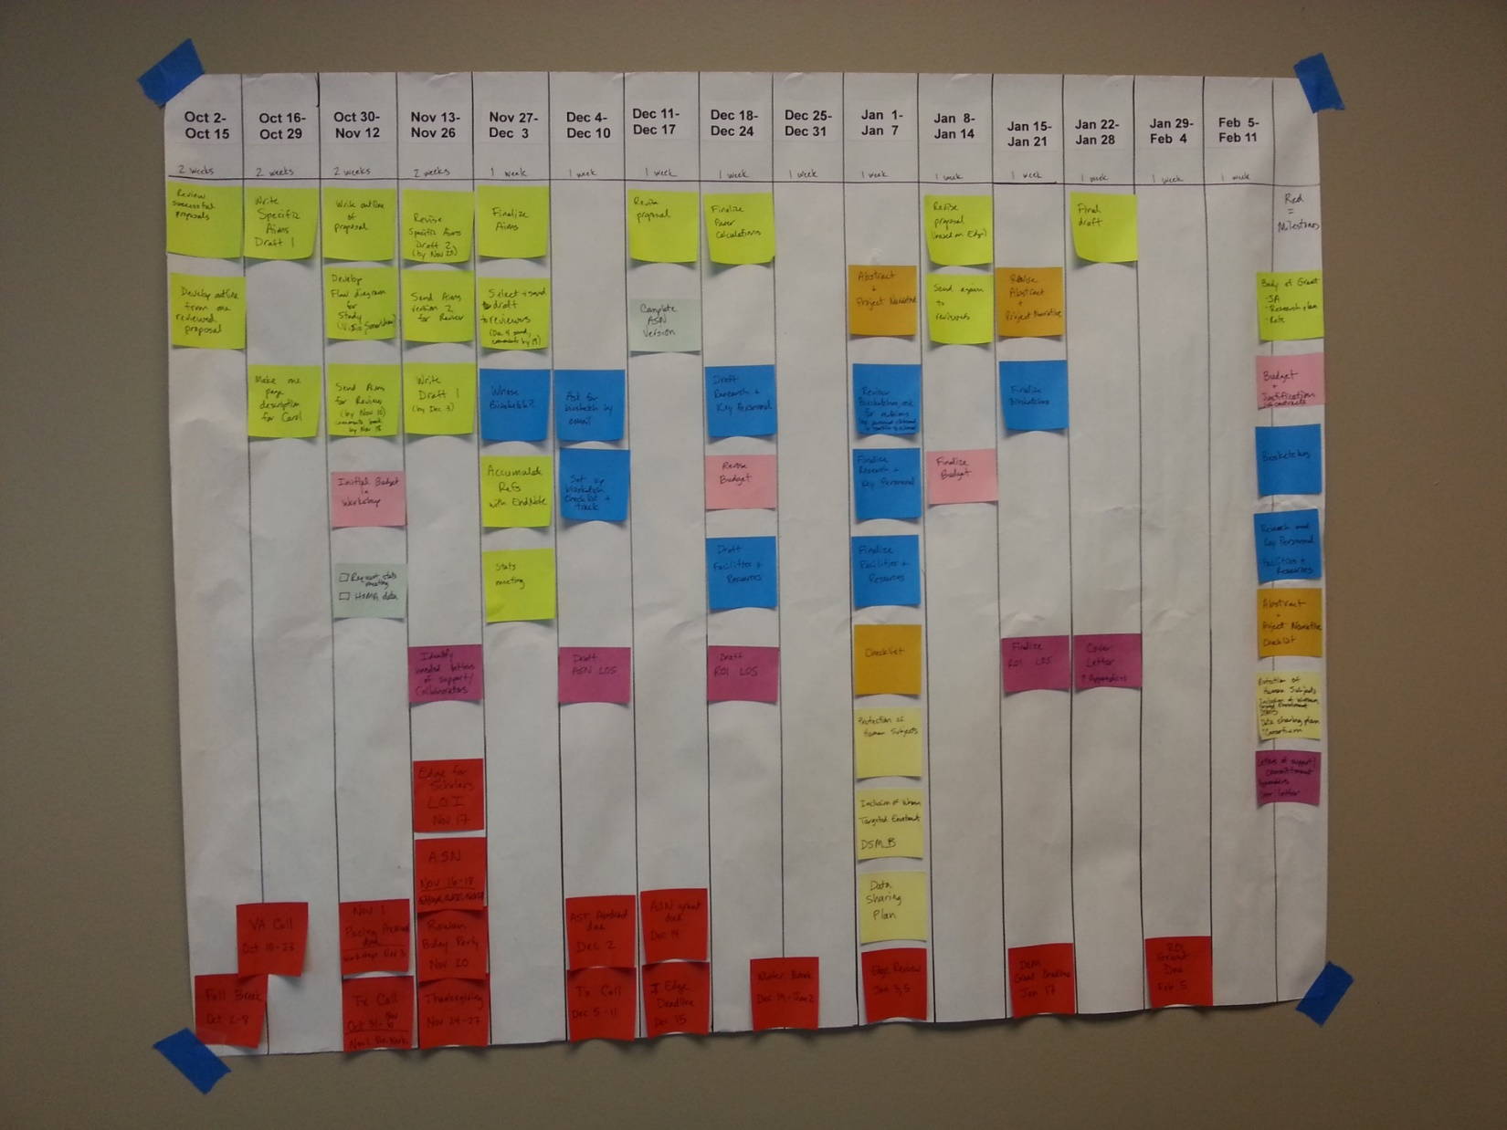

**Milestones**

**Legend for timeline**

**(Buckets of work)**